Lab 12.7.4 – Identify IPv6 Addresses

# Topology

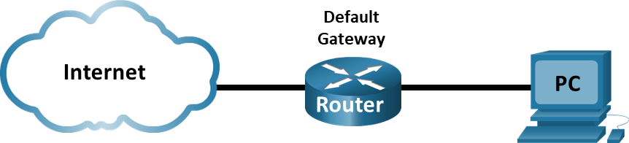

# Objectives

Part 1: Practice with Different Types of IPv6 Addresses

Part 2: Examine a Host IPv6 Network Interface and Address on Windows Computer

Part 3: Examine a Host IPv6 Network Interface and Address on a MAC

# Background / Scenario

With the depletion of the Internet Protocol version 4 (IPv4) network address space and the adoption and transition to IPv6, networking professionals must understand how both IPv4 and IPv6 networks function. Many devices and applications already support IPv6. This includes extensive Cisco device Internetwork Operating System (IOS) support and workstation/server operating system support, such as that found in Windows and Linux.

This lab focuses on IPv6 addresses and the components of the address. In Part 1, you will identify the IPv6 address types and IPv6 addresses abbreviation. In Part 2 and 3, you will view the IPv6 settings on a PC and a MAC depending on your computer type.

# Required Resources

* Use your own PC to complete this Lab. NetLab is not required.

# Instructions

* Enter your screenshots/answers below the items highlighted in blue and turn in the completed file without making any changes to the original content.
* Once the Lab is graded it cannot be resubmitted for a new grade.

## Practice with Different Types of IPv6 Addresses

In this part, you will identify the different types of IPv6 addresses and practice compressing and decompressing IPv6 addresses.

### Match the IPv6 address to its type.

Match the IPv6 addresses to their corresponding address type. Notice that the addresses have been compressed to their abbreviated notation and that the slash network prefix number is not shown. Some answer choices must be used more than once.

Answer choices:

* + - 1. Loopback address
      2. Global unicast address
      3. Link-local address
      4. Unique-local address
      5. Multicast address

| IPv6 Address | Answer |
| --- | --- |
| 2001:0db8:1:acad::fe55:6789:b210 (5 points) | b. Global unicast address |
| ::1 (5 points) | a. Loopback address |
| fc00:22:a:2::cd4:23e4:76fa (5 points) | d. Unique-local address |
| 2033:db8:1:1:22:a33d:259a:21fe. (5 points) | b. Global unicast address |
| fe80::3201:cc01:65b1 (5 points) | c. Link-local address |
| ff00:: (5 points) | e. Multicast address |
| ff00::db7:4322:a231:67c (5 points) | e. Multicast address |
| ff02::2 (5 points) | e. Multicast address |
| fe80::1 (5 points) | c. Link-local address |

### Identify Multicast addresses.

Identify the type of the following multicast addresses:

* + - 1. FF02::1 (5 points) Type = All nodes address (Multicast)
      2. FF02::2 (5 points) Type = All nodes address (Multicast)
      3. **FE80::5054:FF:FE1C:E726.** (5 points) **Type = Not a multicast address (Link-local address)**

### Practice compressing and decompressing IPv6 addresses.

Using the rules of IPv6 address abbreviation, either compress or decompress the following addresses:

* + - 1. 2002:0ec0:0200:0001:0000:04eb:44ce:08a2 (5 points)

2002:ec0:200:1::4eb:44ce:8a2

* + - 1. fe80:0000:0000:0001:0000:60bb:008e:7402 (5 points)

fe80:0:0:1::60bb:8e:7402

* + - 1. fe80::7042:b3d7:3dec:84b8 (5 points)

fe80:0:0:0:0:7042:b3d7:3dec:84b8

* + - 1. ff00:: (5 points)

ff00:0:0:0:0:0:0:0

* + - 1. 2001:0030:0001:acad:0000:330e:10c2:32bf (5 points)

2001:30:1:acad::330e:10c2:32bf

## Examine a Host IPv6 Network Interface and Address (Complete this Part if you are using a Windows Computer, if you are using a MAC, skip and complete Part 3 instead)

In Part 2, you will check the IPv6 network settings of your PC to identify your network interface IPv6 address.

### Check your PC IPv6 network address settings.

Verify that the IPv6 protocol is installed and active on your PC. The instructions below apply to a Windows 10 PC, if you have a different type of computer, research the instructions online and proceed to part h.

* + 1. Navigate to the **Control Panel**.
    2. In the Category View, click **Network and Sharing Center** icon. Click **View network status and tasks**.
    3. In the Network and Sharing Center window, you will see your active networks.
    4. On the left side of the window, click **Change adapter settings**. You should now see icons representing your installed network adapters. Right-click your active network interface (it may be an **Ethernet** or a **Wi-Fi**), and then click **Properties**.
    5. In the Properties window, scroll through the list of items to determine whether IPv6 is present, which indicates that it is installed, and if it is also check marked, which indicates that it is active.
    6. Select the item **Internet Protocol Version 6 (TCP/IPv6)** and click **Properties**. You should see the IPv6 settings for your network interface. Your IPv6 properties window is likely set to **Obtain an IPv6 address automatically**. This does not mean that IPv6 relies on the Dynamic Host Configuration Protocol (DHCP). Instead of using DHCP, IPv6 looks to the local router for IPv6 network information and then auto-configures its own IPv6 addresses. To manually configure IPv6, you must provide the IPv6 address, the subnet prefix length, and the default gateway. Click **Cancel** to exit the properties windows.

**Note**: The local router can refer host requests for IPv6 information, especially Domain Name System (DNS) information, to a DHCPv6 server on the network.

* + 1. After you have verified that IPv6 is installed and active on your PC, you should check your IPv6 address information.
    2. Open a command prompt and type **ipconfig /all** and press Enter. Provide a screenshot of the output. (5 points)

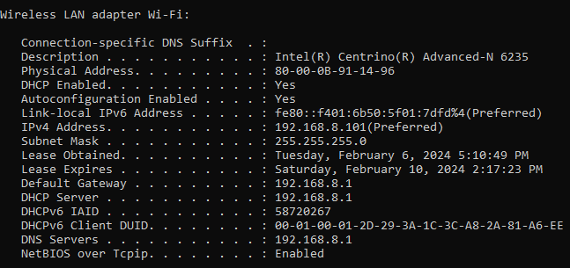

* + 1. What kind of IPv6 addresses did you find when using **ipconfig /all?** (5 points)

The IPv6 address shown is:fe80::f401:6b50:5f01:7dfd%4(Preferred)

This address is a Link-local IPv6 address. You can identify it by the prefix fe80::/10, which is reserved for link-local addressing in IPv6.

* + 1. Provide a screenshot of a ping from your PC to the IPv6 address of the default gateway. (5 points)

It only shows the IPv4 address for the default gateway, which is **192.168.8.1**

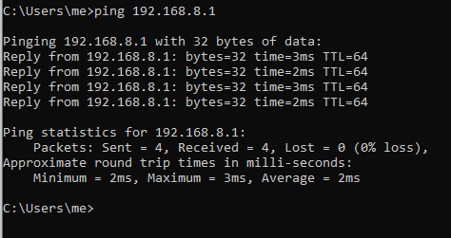

## Examine a Host IPv6 Network Interface and Address (Complete this Part if you are using a MAC, if you are using a PC, complete Part 2 instead)

In Part 3, you will check the IPv6 network settings of your MAC to identify your network interface IPv6 address.

### Check your MAC IPv6 network address settings.

Verify that the IPv6 protocol is installed and active on your MAC. The instructions below apply to a MAC with Sonoma 14.1.1 macos, if you have a different macos installed the configuration may differ from the steps below, research the instructions online and make the necessary adjustments.

* + 1. First, click the **Apple icon** in the top left corner.
    2. From this menu, click “**System Preferences**”.
    3. Next, click on the active interface of your MAC, see screenshot below where **Wi-Fi** is the active interface. A screenshot of a computer

       Description automatically generated
    4. Click Details, see screenshot above, to obtain addressing configuration on the active interface of your MAC. Then Select TCP/IP to see IPv4 and IPv6 addressing. Note the **Configure IPv6** setting. The “**Automatically**” option shown in the screenshot below, allows the MAC to work with the router to generate its IPv6 addressing dynamically.

* + 1. Provide a screenshot like the one above. (5 points)

* + 1. What kind of IPv6 addresses did you find in the output above**?** (5 points)
    2. Open the **Terminal** App from the **Utilities** folder.

* + 1. From the Terminal prompt, issue a ping to the IPv6 address of your router (default gateway) that uses the active interface. See screenshot below where the active interface is en0. You can find the active interface label on your MAC by examining the output of **ifconfig** from the Terminal prompt.

* + 1. Provide a screenshot like the one above. (5 points)